Network communications

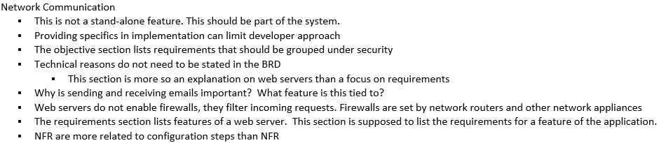

Layout:

* For each feature determine:
  + Define a series of phases that must be completed to accomplish the feature.
    - Phase 1:
    - Phase 2:
    - Phase 3:
    - Phase 4:
  + Resources necessary
    - Amount of time it will take for the feature to be completed and start the feature: TIME =
  + Who will be responsible for its execution?
  + Identify any interdependencies.
    - Do certain tasks need to be completed b4 others begin
    - Do other features need to be completed before this feature?
* set milestones for overall project